My Grocery Store

I own a grocery store that has a point-of-sale system. I want to add a "Deals" feature to it. My requirements are pretty easy, I think. I already have a scanner, so you don't have to worry about that. The scanner has some magic in it that, when my clerks scan a barcode, it adds the item into the current sale.

I have a very limited inventory:

|  |  |  |
| --- | --- | --- |
| SKU | Item | Price |
| 1245 | Bananas | $1.25 |
| 839 | Rubber bands | $10 |
| 99999 | Pepto Bismol | $4.88 |

1. Every morning, before the store opens, I want to configure the deals for the day.
2. For an item that doesn't have a deal, it just costs the normal price.
   1. $1 off the normal price of an item.
   2. 10% off the normal price of an item.
   3. Buy two items, get one item free.

At the end of the sale, I want the point-of-sale system to calculate the total of the items being purchased. Because my store is in Belize, we don't have to worry about sales tax or VAT.

The next page has something called a "class diagram" that my last developer created before he left me for a younger, sexier boss. I don't know what it is for, but he said you might want to see it, so I included it.

There are also some test barcodes on the last page.

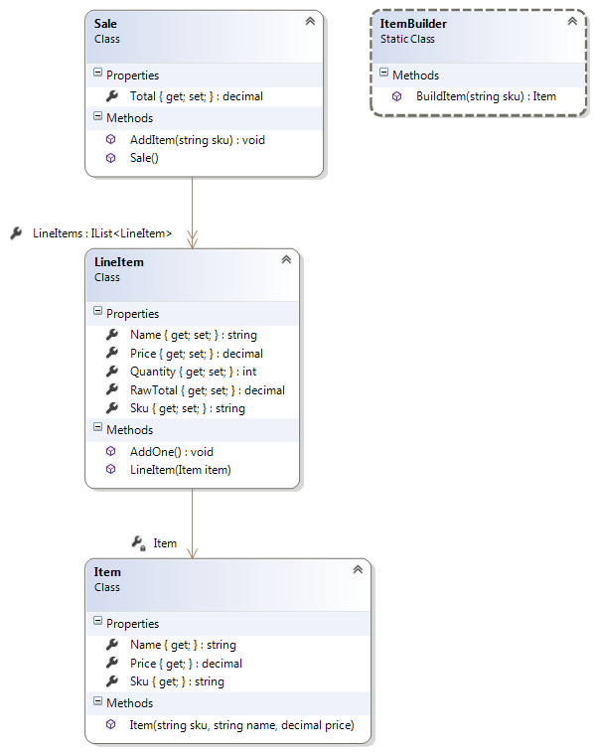

Example Barcodes (Code39) for Testing

**Bananas**:

1245

**Pepto Bismol**:

99999

**Rubber Bands**:

839